PHOENIX YOUTH FC FC RISK ASSESSMENT – COVID-19 – UPDATED 30/07/20

Key points from FA guidance (18/07/20):

Until 31 July – When ready, you can begin competitive training, with the overall group size (inclusive of coaches) being limited to 30 people;
From August – Competitive matches to begin, for example pre-season fixtures, festivals and small sided football competitions;
From September – Grassroots leagues, men’s National League System, Women’s Football Pyramid tiers 3 to 6, and FA Competitions can commence.

A SUMMARY OF KEY POINTS TO CONSIDER FROM THE FA’S GUIDELINES ARE LISTED FOR EASE BELOW:
• Everyone should self-assess for COVID-19 symptoms before every training session or match. If you are symptomatic or living in a household with possible or actual COVID-19 infection you must not participate or attend;
• Clubs and facility providers should ensure that their facility is compliant with current Government legislation and guidance related to COVID-19;
• Competitive training is now permitted, with groups limited to a maximum of 30 people, including coaches;
• Competitive match play is permitted, with social distancing in place before and after the match, and in any breaks in play;
• Players and officials should sanitise hands before and after a game as well as scheduled breaks throughout a game or training session;
• Ball handling should be kept to a minimum with most contact via a boot and the ball disinfected in breaks of play;
• Youth football coaches are encouraged to limit persistent close proximity of participants during match play and training;
• Goal celebrations should be avoided;
• Equipment should not be shared, and goalkeepers should ensure they disinfect their gloves regularly in breaks in training or matches and thoroughly afterwards. Where possible, coaches should only handle equipment in training;
• Where possible, players, coaches and officials should arrive changed and shower at home. Use of changing and shower facilities must follow government advice on the use of indoor facilities;
• Participants should follow best practice for travel including minimising use of public transport and walking or cycling if possible. People from a household or support bubble can travel together in a vehicle
• Clubs should keep a record of attendees at a match or training session, including contact details, to support NHS Test and Trace;
• Clubs should ensure they are affiliated with their County Football Association.
• At this stage, indoor football and futsal is not permitted.

LISTENING TO CHILDREN

You may be one of the first people outside the family unit that a child has met in recent times. It’s important that you know some children may be struggling for various reasons: lacking confidence, being confused and stressed about social distancing, they or someone they care about may have been or may still be unwell; they may be grieving; they may be worried about their particular vulnerabilities; they may have experienced neglect; children with learning difficulties may find it particularly confusing as their routine has changed. During lockdown there has been an increase in domestic violence, online grooming of children, cyberbullying. Coaches must remain vigilant because of your important role in safeguarding. If you are concerned for the welfare of a child, contact your Club Welfare Officer, County FA designated Safeguarding Officer or the NSPCC on 0808 800 5000. If it is an emergency because a child is at immediate risk, call the police on 999.

GRASSROOTS CLUB SAFEGUARDING RISK ASSESSMENT

EVENT DETAILS
Phoenix Youth FC Training sessions and friendly matches

VENUE |  |  | EMERGENCY PROCEDURES
VENUE ADDRESS | Ferndown Leisure Centre | EMERGENCY ACTION PLAN: |  | As per website
VENUE LEAD CONTACT NAME | Jez Horgan, Club Secretary | LOCATION OF NEAREST DEFIBRILLATOR |  | Leisure Centre Reception
CLUB WELFARE OFFICER | Jez Horgan | LOCATION OF ANY ACCESS BARRIER KEYS, EMERGENCY VEHICLE ACCESS |  | Leisure Centre Reception
CLUB COVID-19 OFFICERS | Jez Horgan

CLUB POLICIES AND PROCEDURES BEING FOLLOWED | YES | NO
Safeguarding Children | Yes
Social Media Use | Yes
Use of photography and filming | Yes
Anti-bullying | Yes
Code of conduct, including acceptable behaviour | Yes
Other: GDPR/Privacy Notice | Yes
Personal Accident and Public Liability Insurance Cover | Yes

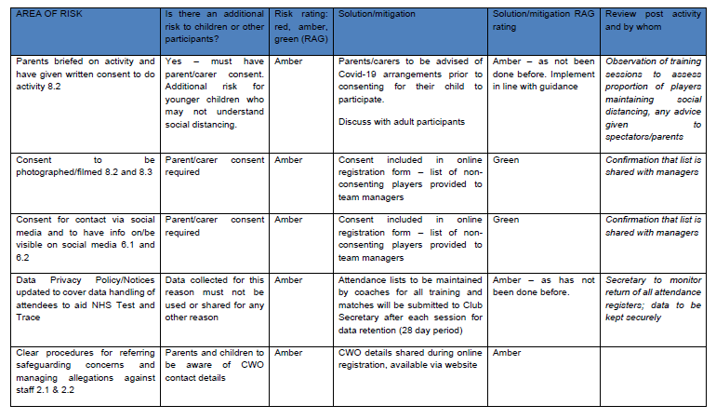

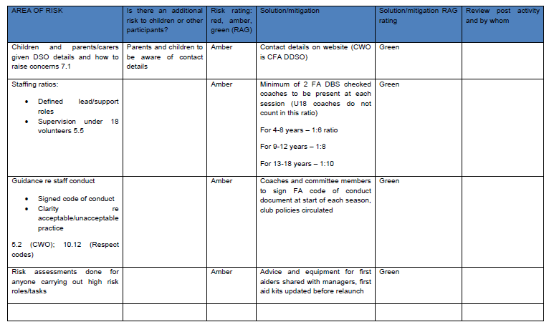

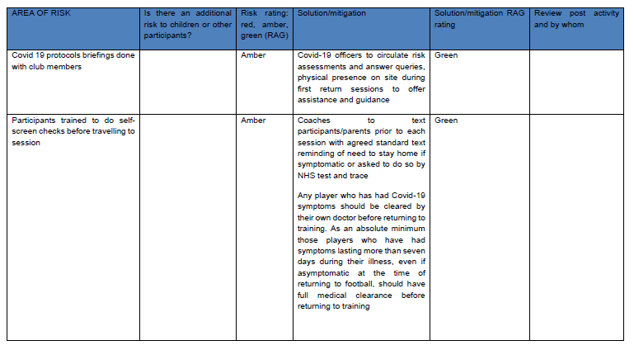

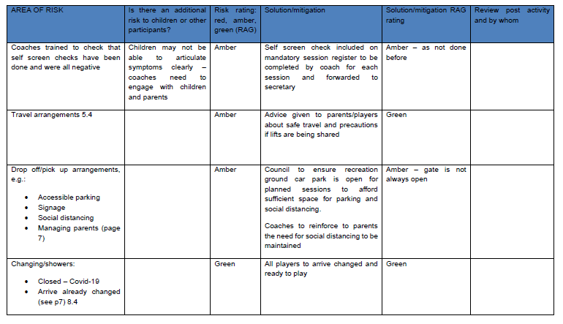

AREA OF RISK | Is there an additional risk to children or other participants? | Risk rating: red, amber, green (RAG) | Solution/mitigation | Solution/mitigation RAG rating | Review post activity and by whom
Access to toilets, e.g.  • Supervision  • Hand-washing and/or rub ‘washing’ facilities  • Paper towels and sealed bins or double-bagged (see p6) | Children require supervision to ensure hygiene | Amber | Leisure Centre toilets are available – One way system in place – hand sanitiser in place on exit, electric hand dryers will not be in use. Players to be advised to use the toilet at home before attending sessions in order to avoid use of toilet facilities. | Amber
Site boundaries, e.g.  • Public access  • Roads  • Location of facilities  • Drop-off point and access to pitches/training areas |  | Amber | Zones for different teams to be marked off using cones or respect barriers, cones to be used to demarcate 2m intervals

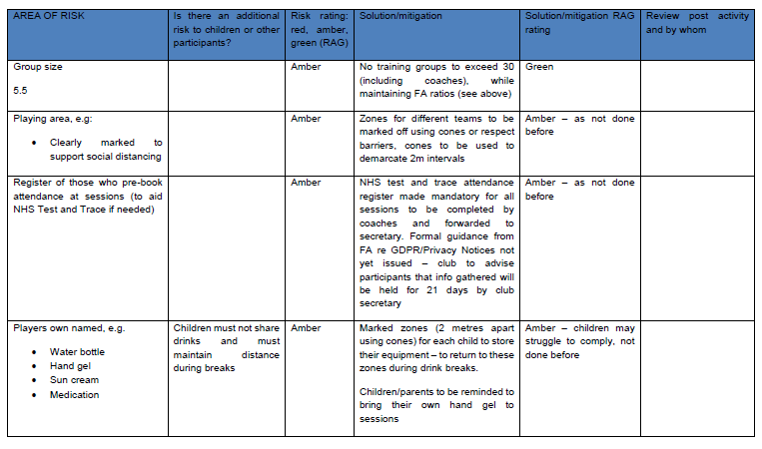

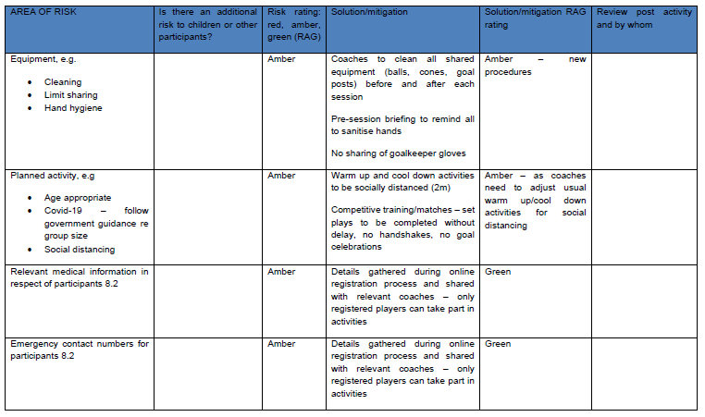

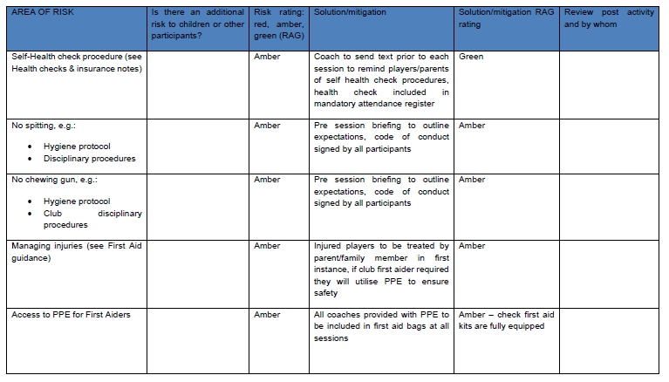

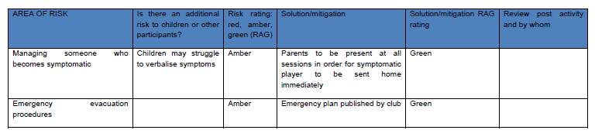

Risk assessment completed by:
Name: Jeremy Horgan
Club Role: Secretary & CWO – Covid-19 Officers
Signature: Jez Horgan
Date: 30/07/20
Checked by Club Committee:
Name: Nigel Phillips, Dave Whiteman, Craig Richmond-Cole, James Baldwin
Club Role: Committee
Signature: Nigel Phillips, Dave Whiteman, Craig Richmond-Cole, James Baldwin
Date:30/07/20

Guidance for End of season celebrations/presentation events

Due to Covid-19 restrictions, the club is unfortunately unable to hold a presentation day event this year to mark the end of the 2019/20 season. Individual teams have now taken delivery of club trophies for each squad. Managers are asked to consider the latest FA and Government guidance detailed in this risk assessment to inform planning of any celebratory events. Current guidance states that you should “not hold or attend celebrations (such as parties) where it is difficult to maintain social distancing” https://www.gov.uk/government/publications/staying-alert-and-safe-social-distancing/staying-alert-and-safe-social-distancing-after-4-july

• Training sessions are currently limited to a maximum of 30 attendees (including coaches) – the club’s risk assessment has been completed to cover training and matches for distinct groups of no more than 30 players at the Recreation ground. On this basis we cannot, therefore, authorise any events that will be attended by larger numbers of people or held at other venues.
• FA guidance outlines that although there is a return to competitive training and matches, social distancing should be maintained outside of these situations – any presentation event needs to comply with current Government guidance regarding social distancing – maintaining 2 metre distancing wherever possible (1+metres as a minimum). Presentations should not, therefore, involve traditional handshakes, etc.

We recognise that these limitations are disappointing but urge all managers to arrange presentations in accordance with established guidance.

Covid-19 Guidance on Restarting Outdoor Competitive Grassroots Football – SUMMARY GUIDANCE
Guidance for Coaches

THE DAY BEFORE ANY PLANNED ACTIVITY
1. Send template Whatsapp message to all players asking them to complete self check for symptoms (see Appendix 1)

BEFORE ACTIVITY
1. Make sure you have read the club’s updated risk assessment and discussed it’s implications with the club’s Covid-19 officer – Jez Horgan – who will monitor compliance across the club
2. Prior to each session, check for symptoms of Covid-19 – if you are symptomatic and/or living in a household with a possible Covid-19 infection you should remain at home and follow Government guidance. If you have been asked to isolate by NHS Track and Trace because you are a contact of a known Covid-19 case, you must not exercise outside your home or garden and must not exercise with others.
3. On arrival at venue, please ensure social distancing in and around the car park and before and after training/match sessions – this should be a distance of 2 metres whenever possible (1+ metres as a minimum)
4. Prior to each session, complete a safety briefing to remind both sets of players and officials about their responsibilities in complying with the code of behaviour (see Appendix 2)
5. Each player should be allocated a spaced area (marked with cones) to store equipment, refreshments, etc – 2m spacing between each player’s zone
6. Maintain an accurate register of each session and forward this information to Secretary, Jez Horgan, to store information in order to support NHS test and trace efforts. Competitive training can take place in groups of no more than 30 people (including coaches)
7. Goal posts, slalom poles etc should be wiped down before the session starts
8. If you are arranging a friendly match please ensure that the other team are FA affiliated, inform Secretary (Jez Horgan) of your intentions (date, time and location of match) and ask the opposing team to provide details of their club’s covid-19 officer. If an Away game, the away club’s Covid-19 officer must attest that they have ensured their club and facilities are compliant with all elements of guidance and all Risk Assessments have been completed

DURING ALL FOOTBALL ACTIVITY
1. Before and after the session, and in any breaks, all participants should practise social distancing, in line with guidance on 2 metres or 1 metre plus.
2. No pre-match handshakes
3. No team talk huddles – socially distanced team talks only
4. Bibs should not be used unless you intend to allocate named bibs to individual players for them to take home and wash after each session
5. Warm ups and cool downs must observe social distancing
6. Coaches and substitutes must observe social distancing on touchlines
7. During matches, set plays should be taken without unnecessary delay to limit prolonged close marking
8. Goal celebrations should be avoided
9. Small sided football should be modified to provide more regular hygiene breaks (4 quarters rather than 2 halves)
10. Any payments in relation to the session (e.g. minis and wildcats) should, where possible, be made in a cashless manner.
11. Avoid the sharing of equipment – if it is shared it should be cleaned before use by another person. Players should take their own kit home to wash themselves, rather than have one person was the team kit.
12. When the ball goes out of play it should not be retrieved by non-participants and should be retrieved using feet rather than hands
13. There is additional risk in close proximity situations where people are shouting or conversing loudly – avoid shouting or raising voices when facing each other during, before or after games
14. No spitting
15. If a player is injured, a member of their household can assist if present. If a first aider is required, they should be equipped with PPE (including face coverings) to protect themselves if they need to compromise social distancing to provide medical assistance. After contact, first aider should sanitise hands.
16. If a player becomes Covid-19 symptomatic during the activity, they should immediately go home and follow NHS guidance.
AFTER THE SESSION
1. After matches where team kit has been worn, each player should take their kit home to be washed separately.
2. Wash your hands at the earliest opportunity and wipe down any personal equipment with disinfectant
3. Identify who will be responsible for cleaning all shared equipment - ensure that all equipment is collected from the field, thoroughly clean the equipment (balls, cones, goalposts). Maintain a record of regular cleaning of club or team equipment (see attendance register document)
4. Maintain social distancing when leaving the venue
5. Send Track and Trace attendance register to Secretary, Jez Horgan

Guidance for parents of youth players
1. Prior to each session, check for symptoms of Covid-19 – if you are symptomatic and/or living in a household with a possible Covid-19 infection you should remain at home and follow Government guidance. If you have been asked to isolate by NHS Track and Trace because you are a contact of a known Covid-19 case, you must not exercise outside your home or garden and must not exercise with others.
2. We recognise that the period of isolation caused by lockdown may have caused some children to become anxious or unsure about resuming activity. Please speak to your team coach of this is an area of concern so that we can work with you to manage gradual introductions if needed.
3. If you choose for your child to take part, you will need to give your written/email consent to the club and or coach. Ensure that you are comfortable with the club’s Covid-19 planning arrangements before you do so.
4. Your child must arrive changed and ready to play. Toilets will be available if needed, but children should be encouraged to use the toilet before leaving home.
5. Ensure your child takes their own water bottle and their own hand sanitiser, sun cream and any medication (e.g. inhaler), all clearly marked with their names. They must not share these with anyone else.
6. Please ensure your child knows how to maintain good hygiene and hand washing – no spitting, chewing gum, maintaining social distance.
7. On arrival at venue, please ensure social distancing in and around the car park and before and after training/match sessions – this should be a distance of 2 metres whenever possible (1+ metres as a minimum)
8. Any spectators at training sessions must be restricted to discrete 6 person gathering limits, spread out. Parents must remain within sight of the session as you will be called upon to undertake any first aid treatment in the first instance – you can watch the session from your car or can stand at the side of the pitch whilst observing social distancing
9. There is additional risk in close proximity situations where people are shouting or conversing loudly – spectators should avoid shouting or raising voices when facing each other during, before or after games
10. If a football goes out of play, it should not be retrieved by non-participants and should be retrieved using the feet rather than hands where possible.

Appendix 1 – WHATSAPP MESSAGE SENT PRIOR TO EACH SESSION
Standard Message to be sent to all players by team managers via Whatsapp groups prior to each session (see template shared on Managers Group)
FOOTBALL SELF SCREEN CHECK LIST REMINDER

BEFORE you come to your next Phoenix session, ask yourself/your child whether you have:
• A high temperature (above 37.8C)?
• A new continuous cough?
• Shortness of breath?
• Sore throat
• Loss of or change in normal sense of taste and smell
• Do you feel generally unwell?
• Have you been in close contact/living with a suspected or confirmed case of COVID-19 in the previous two weeks?

If you answer YES to any of these questions, you should not attend training/friendlies and should follow all applicable Government Guidance (e.g. call NHS 111)

Appendix 2 – SAFETY BRIEFING TO BE DELIVERED BY THE COACH BEFORE EACH SESSION
To remind players and spectators before each session of the following points:
• Everyone should maintain social distancing of 2 metres wherever possible – this includes before and after the session, during any warm up or cool down activities.
• Ask everyone to wash/hand gel their hands before the session, during any break and at the end of the session
• If you need to retrieve a ball, do so with your feet rather than your hands – it’s good practice!
• Do not share your drink bottle, hand gel or goal keeping gloves with anyone else. Keep all of your equipment in your designated zone
• No spitting or chewing gum
• If you feel unwell, tell your coach
• When the session is over, please leave the venue quickly, maintaining social distancing

